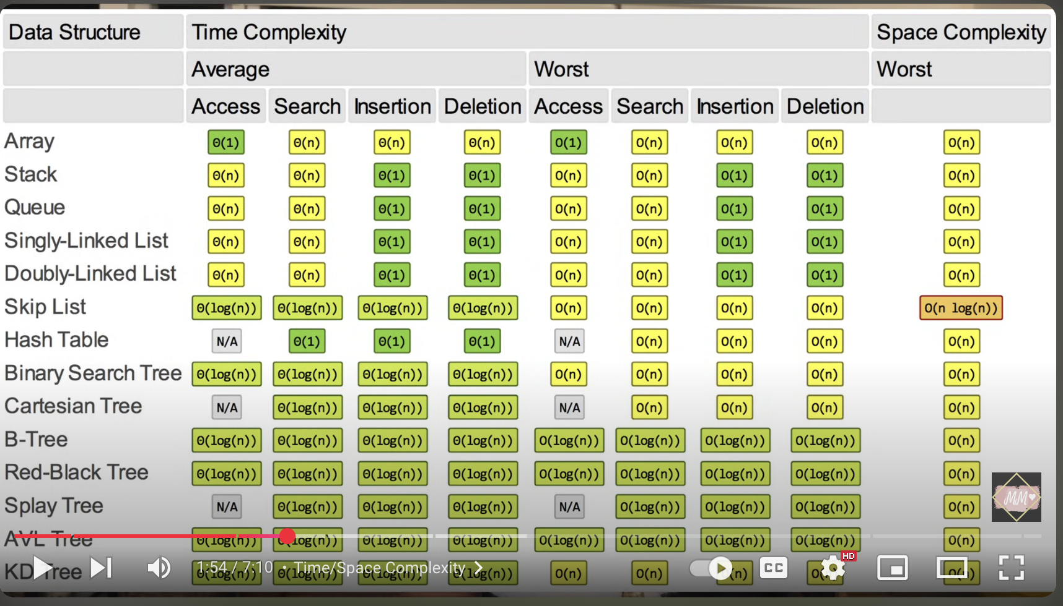

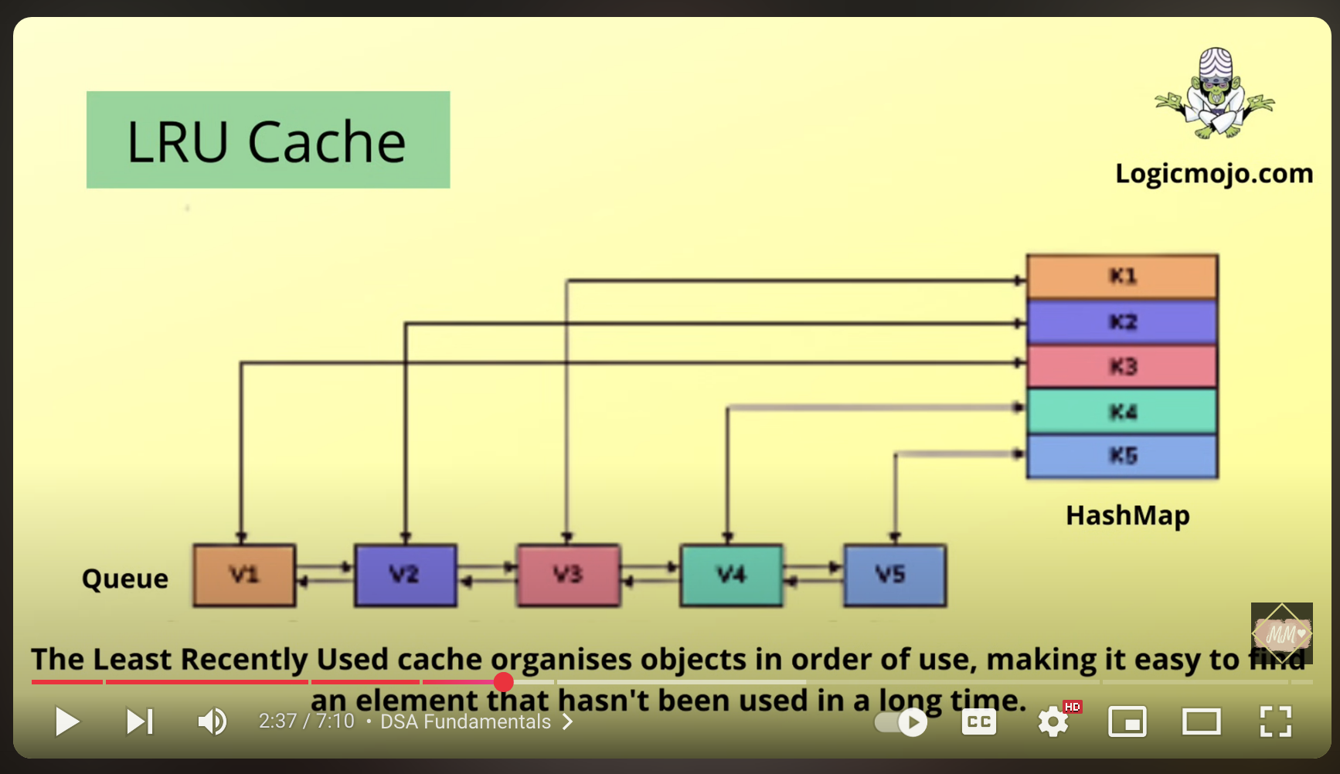

Remove duplicates, modify accordingly, and ensure the latest updates. Maintain a clean, clear, and smooth website.

